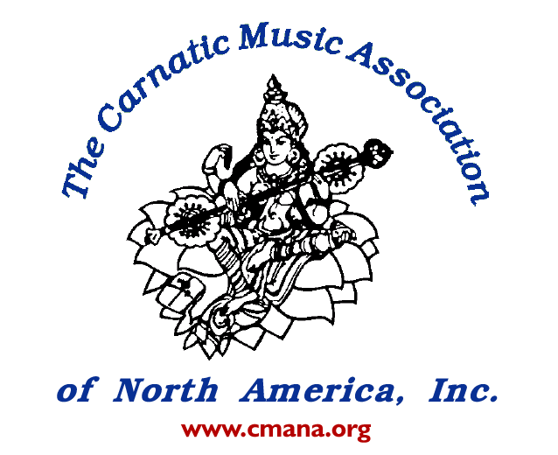
Tfas
Carnatic Music Association of North America, Inc.
&
Telugu Fine Arts Society, NJ
Present a Carnatic Vocal Concert by

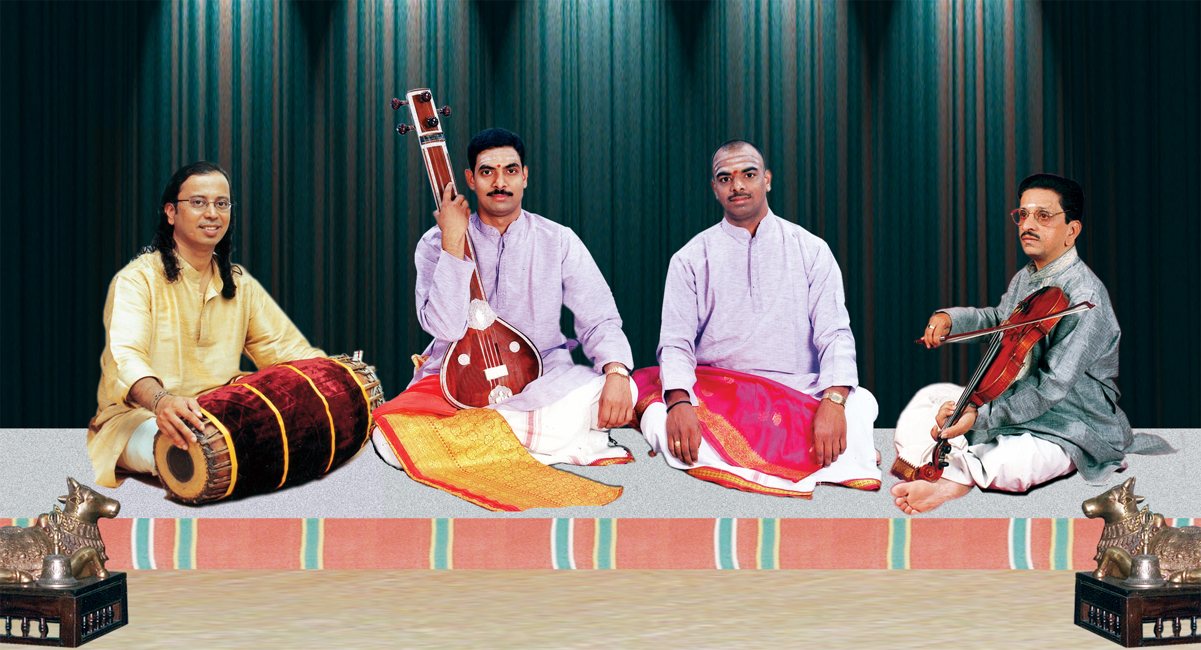

Malladi Brothers
Sri Sreeram Prasad (Vocal) and Sri Ravikumar (Vocal)
Sri Peri Sriramamurhty (Violin)
Sri Poovalur Srinivasan (Mrudangam)
Saturday, June 21, 2003 4.00 PM
HTCS Bridgewater Temple Auditorium,
Bridgewater, NJ

About the Artists :

MALLADI BROTHERS: Malladi Brothers Sreeram Prasad and Ravikumar were born with a legacy and rich tradition accrued through their grand father Late Malladi Srirama Murthy and through their father a great Harikatha exponent of his time in Andhra Pradesh. Both the brothers received musical training from their father- vocalist, Malladi Suri Babu, himself a disciple of the great Late Voleti Venkateswarulu. Sangeetha Kalanidhi Nedunuri Krishnamurthy realizing the potentials of Malladi Brothers took them under his guidance to represent his rich style of music.

Malladi brothers possess a large repertoire of Carnatic compositions and possess a vibrant and powerful voice. The brothers have been the most sought after young maestros. They have traveled extensively all over India and abroad promoting and preserving the rich traditional music they represent. Malladis have several audio publications to their credit.

Sri Peri Sriramamurthy: A senior violinist in the south Indian tradition, Peri was trained by his father Subba Rao of Kakinada, Andhra Pradesh. He has had nearly 3 decades of experience playing for all top artistes of the country and has earned reputation for his purity and classical values. His names appear on scores of audio recordings, a standing testimony for his popularity as an accompanist. Peri has been on several foreign tours including that of USA, Canada, Europe and Australia. He is currently a staff at the Government Music College, Hyderabad.

Poovalur (SRIJI) Srinivasan: A prolific composer, performer, educator studied South Indian Classical music from his father P.A. Venkataraman. For over twenty-five years Poovalur has performed with the leading artist from both South and North Indian Classical traditions. Since his move to the United States Poovalur has performed and recorded with various artists, such as Sir Yehudi Menuhin, Bela Fleck, Mark O' Connor, John Bergamo, Glen Velez to name a few. He has composed several pieces portraying the South Indian idioms. Poovalur has received several awards from leading institutions, and the album Tabula Rasa, where he has composed and performed with Bela Fleck, V. M. Bhatt and J.P. Chen was nominated for a Grammy. Poovalur has taught Music at San Diego State University and Calarts and currently a faculty at University Of North Texas at Denton.

Directions to HTCS Temple Auditorium :

From New York City: Take George Washington Bridge, Lincoln/Holland Tunnel to NJ Turnpike South. Take Exit 14 to 78 West. Take Exit 29 to I 287 North. Take 287 North to Exit 22A (202/206 South). Pass trough 4 lights (approximately 3 miles) make first right onto Old Farm Road. The Temple is on the left.

From Route 80: Take 287 South to Exit 22 (Pluckemin). After the exit keep right and immediately follow jug handle U -Turn to 202/206 South. Pass 5 lights and make first right on to Old Farm road. Temple is on the left.

From PA and South Jersey: Take US Route 1 North or NJ Turnpike North to I - 287 North to Route 22 West (Left Exit). Travel approximately 3 miles and take 202/206 North. (towards Morristown) Travel approximately 5 miles. After you pass the Aventis pharmaceutical Bldg., and one traffic light, (Brown Road) make a first left onto Old Farm Road. Temple is on the left.

Tickets :

$13 - CMANA and TFAS members , $16 - non-members of CMANA or TFAS
$ 10 – students (with proper ID) & senior citizens

For details contact :

Asha Janardhan – 908 – 875 – 6072
Mangalam Chidambaram – 609 – 275 – 5786
Y. Chandramouli – 732 – 432 – 9663

Satyaveni Rao - (973) 887-6152
Anantha Sudhaker Uppala - (732) 906-9460
Bhanu Chivukula - (732) 767 1955
Radha Kasinadhuni-973-366-2177

