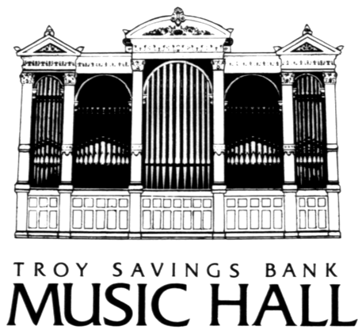 FOR IMMEDIATE RELEASE
Contact: Terry Tyson
518-438-2826

THE TROY SAVINGS BANK MUSIC HALL

PRESENTS

ETHOS PERCUSSION GROUP
with special guest artists Pandit Samir Chatterjee and Pandit Ramesh Misra

Saturday, March 6th at 8 p.m.

Tickets: $25 and $22
(518) 273-0038

Media Sponsor: Times Union, Time Warner Cable and Metroland
This program is made possible by public funds from the NYS Council on the Arts, a State agency

TROY, N.Y., FEB. 12— Incorporating traditional instruments and compositions from the Pacific Rim, South America, India, and Africa, the Ethos Percussion Group has developed a sound that the Washington Post has called “spellbinding.” Ethos, together with special guest artists Pandit Samir Chatterjee and Pandit Ramesh Misra, brings their show to the Troy Savings Bank Music Hall on Saturday, March 6th at 8 p.m., for a performance that wonderfully embodies the term “world music.”
“The virtuoso playing of all four members within this ensemble setting is marvelous and never dull,” writes Percussive Notes. Since 1990, the group, composed of members Trey Files, Eric Phinney, Michael Sgouros and Yousif Sheronick, has crossed innumerable boundaries in the world of percussive chamber music, playing Western drums and cymbals alongside instruments such as the Japanese okaido and the African shekere. Ethos has released two albums, premiered numerous original compositions by
MORE

ETHOS PERCUSSION GROUP—2-2-2
emerging composers, and offers a popular program called “Bing! Bang! Boom!,” which has taught schoolchildren in 35 states about percussive instruments from around the globe. Members also perform individually with the American Symphony, the New World Symphony, the Gertrude Stein Repertory Theater, and orchestras for various Broadway productions, and serve on the faculties of La Guardia High School for the Performing Arts, Molloy College, and the Concordia Conservatory.
Joining the Ethos Percussion Group on March 6th will be master Indian musicians Pandit Samir Chatterjee on tabla, a traditional two-piece drum, and Pandit Ramesh Misra on sarengi, a stringed instrument comparable to a violin. Pandit Chatterjee is one of India’s premiere tabla players, and has performed with the Dance Theater of Harlem, Ravi Shankar, and Jerry Garcia. Pandit Misra is known worldwide as a master sarengi artist, considered one of the most challenging stringed instruments. He has recorded with Aerosmith on their 1997 release, “Nine Lives,” and was a featured performer on Ravi Shankar’s Grammy-nominated “Legacy” album. Together with Ethos, these two masters combine ancient Hindustani music with modern rhythms, resulting in a groundbreaking performance that promises to be both visually and aurally fascinating.
Reserved seats for the Ethos Percussion Group and special guest artists Pandit Samir Chatterjee and Pandit Ramesh Misra are $25 and $22, and may be purchased by calling the Troy Savings Bank Music Hall Box Office at (518) 273-0038 or online at www.troymusichall.org. The Music Hall Box Office opens one hour prior to the performance. Otherwise, Box Office operations are handled at its business office at 7 State Street, Monday through Friday 10 a.m.-5 p.m., and on Saturdays from 10 a.m. to 1 p.m., on show days only. The Troy Savings Bank Music Hall’s full season schedule can be viewed at www.troymusichall.org.
The Troy Savings Bank Music Hall, named a National Historic Landmark in 1989, is in use over one hundred and fifty days a year. Since it opened its doors in 1875, the Hall has hosted performances by numerous world-renowned artists including Marion Anderson, Dizzy Gillespie, Peter Seeger, Ella Fitzgerald, Isaac Stern, Yo-Yo Ma, Henri Vieuxtemps, Ignace Jan Paderewski, Sergei Rachmaninoff, Jose Iturbi, Vladimir Horowitz, Yehudi Menuhin, and Artur Rubenstein, among many others.
--30—

