GRAND TARANGINI VEENA RECITAL
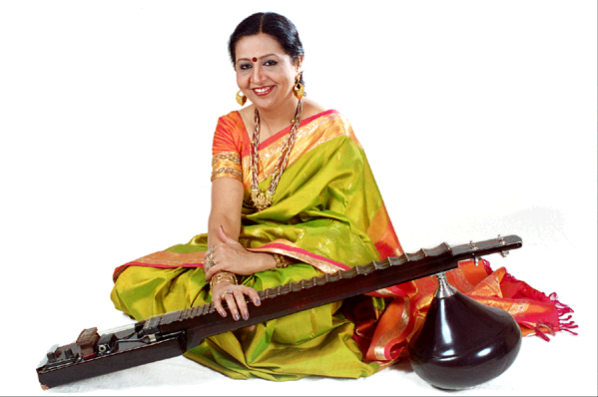
PALLAVI and KANNADA KOOTA OF CAPITAL DISTRICT
In Cooperation with Hindu Temple Society
PRESENT

GRAND VEENA RECITAL

BY

DR. SUMA SUDHINDRA

************************************************************ DATE: SUNDAY APRIL 18TH, 2004

TIME: 2:30 – 4:30 PM
VENUE: HINDU TEMPLE SOCIETY
Artist Profile: Dr Suma Sudhindra is one of the acclaimed Veena artists today. She is a disciple of Veena Maestro late Dr Chittibabu. A balanced blend of the classical conservation and the dynamic spirit of innovations with an aesthetic improvisation make her music distinct. She has performed at prestigious institutions in India and abroad including USA, UK, France, Singapore, and Canada. Dr Suma has won various titles and national awards from Music academies including Madras Music academy, Krishna Gana Sabha. She is currently president for Karnataka music academy and Chowdayya music memorial hall. She is leading well-known Jazz-fusion group “MEGHA”. She also trained several young artists at TARANGINI school of music in Bangalore.

