Hyderabad Sisters Lalitha and Haripriya - Vocal

Bhaskara Lalitha and Bhaskara Haripriya, popularly known as the Hyderabad Sisters, have been in the center stage of classical Carnatic music, performing extensively since the age of twelve. They belong to the Alathur Sishya Parampara, being the disciples of Sangeetha Vidwan Shri. T.G. Padmanabham, a direct disciple of Shri Alathur Venkatesa Iyer. The sisters hail from a highly cultured and accomplished family of Hyderabad, beginning Carnatic vocal training from a tender age of six.
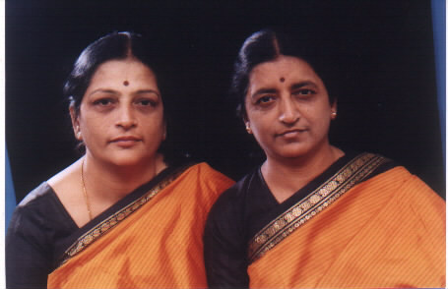
Hyderabad Sisters have won several awards in various sabhas, notable of which is the “Raja Annamalai Award” of the Madras Music Academy in 1994. The unique “Spirit of Unity Concerts” has presented their music several times, including in the presence of Bhagawan Shri SatyaSai Baba in Puttaparthi. Winners of the prestigious All India Radio competitions, the Hyderabad Sisters are “A” grade artists of All India Radio and Doordarshan. Apart from giving regular performances over the radio and television, they have also been featured in the high-status National Programs of Music, Radio Sangeeth Sammelans and the special programs of Doordarshan. They are both on the faculty of the Govt. Music Colleges in Hyderabad and Secunderabad. Well-known music recording companies such as AVM, Sony, Sangeetha, Geetha, Inreco etc. have released several cassettes and CDs of the sisters.

Akkarai Subhalakshmi- Violin

Akkarai S. Subhalakshmi, a child prodigy started giving violin solo and vocal programmes at the tender age of eight. She had her initial two years training at Nadha Brahma Vidyalaya of the late guru V. Janakiraman, New Delhi.
She is now under the guidance of Swara Raga Sudha Violin School run by her father
Akkarai S. Swamynathan. She is not only an expert violinist but also a well recognized vocalist. She is learning vocal music from Padma Bhushan P.S. Narayanaswamy and Chithra Veena N. Ravikiran. She is a direct B-High grade artist of All India Radio, Chennai. She gives violin accompaniment to eminent artists like Dr. M. Balamuralikrishna, Dr. N. Ramani, Chitra Veena N. Ravikiran, Sriram Gangadharan, N. VijaySiva,Shashank, Bombay Sisters, Nithya Shree Mahadevan,Bombay Jayashree, Priya Sisters, Ranjani and Gayatri and others. She also gives classical violin programs all over the country and also in abroad. She has participated in Indo-Russian Cultural exchange program and excelled in violin recital during her visit to Russia in the year 1996. She has also gone to Japan, Germany, Italy, France, Bahrain, United Kingdom and USA for giving violin solo and accompaniment to various Artists. She is also giving violin duet as well as vocal duets along with her younger sister Kum. Akkarai S. Swarnalatha as Akkarai Sisters.

M. Lakshminarayana Raju-Mridangam

Shri. M. Lakshminarayana Raju began learning mrudangam from his father and guru, Shri. M. Radhakrishna Raju and received advanced training from Shri. Dandamudi Ramamohan Rao. He has accompanied several well-known artists including Dr. Balamurali Krishna and Shri. Bhimsen Joshi in the 1987 Jugalbandi concert tour in USA/Canada and Dr. Balamurali's 1990 concert tour in Switzerland. In 1983, he received the Akashvani Annual Award and is one of the youngest top grade A+ artists. He has been bestowed with several titles including "Mrudanga Baaludu" and "Sunaada Sudhanidhi".

This program is made possible in part with public funds from the NYS Council on the Arts Decentralization Program administered in Albany and Schenectady counties by the Albany/Schenectady League of Arts Community Arts Connection.

