HINDU TEMPLE SOCIETY OF CAPITAL DISTRICT
proudly presents
A concert of classical music
Principal Instrument is nadhaswaram
Percussion accompaniment is thavil

Nadhaswaram, a South Indian instrument, is similar to Shenai and Oboe . It is considered a very auspicious instrument and is played at Temples and weddings. The thavil is the authentic accompaniment for nadhaswaram. It is a shell of spherical proportion with both ends open and wrapped with skins. One end is played with a stick and the other with a hand with metal thimbles on the fingers.
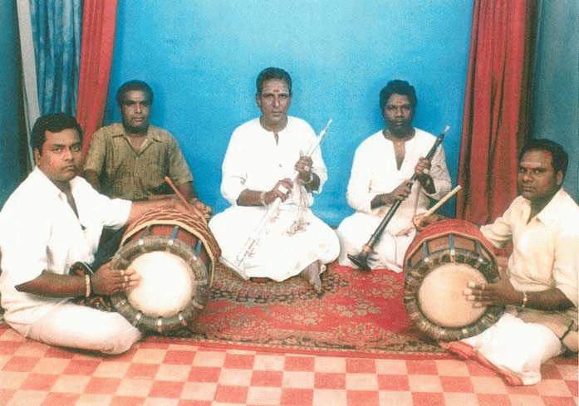

Location : The Hindu Temple (450 Albany Shaker Road )
Date : Saturday, August 14, 2004
Time: 2.30 PM to 5.30 PM
Suggested Donation for Adults: $10 per person.
Artists:
Nadhaswaram: Kalaimamani N.V. Sundaram hails from Tamilnadu, India. He is a virtuoso in nadhaswaram and has been playing it for 40 years. He has several tittles and awards to his credit and is also the “Asthana Vidwan” for the famous Parthasarathy Temple & Ellai Amman Temple in Chennai, India. This is his first visit to the U.S.A, and he has already played in many loactions in US including several Temples.
Ganesan and A.G.Srinivasan have been performing jointly with Mr. Sundaram on Nadhaswaram for the past 20 years. They are also accomplished artists.

Thavil: Rajaraman and Vijayakumar, the two percussionists are well known and have accompanied Mr. Sundaram for over 15 years.
This is a rare opportunity and please plan to attend.
For more information, please contact: Sevugan Chetty (877-6211), K. Bala (783-8722), Dr. N.Bala (346-5125) and Dr. Gattu N.Rao (449-5391).

