PALLAVI OF THE CAPITAL DISTRICT,INC

P.O.BOX 1732

LATHAM, NY 12110
PHONE: 518-273-6634

EMAIL:pallavicapital@ureach.com
Website: www.cs.rpi.edu/~moorthy/pallavi2004/

Newsletter # 4 of 2004

September 9. .2004

Next Major Pallavi Vocal Concert on Saturday October 2

Saturday, Oct 2nd -Purandaradasa Concert by Srimathi Kiranavali (Carnatic Vocal) with Sri Shivkumar Kalyanaraman on violin and Mahalingam Santhanakrishnanon mridangam on October 2, 2004 West Hall Auditorium (RPI), Social Hour: 6-7 PM; Concert starts at 7 PM. - organized jointly with "The Graduate Indian Student Association of RPI". And "Kannada Koota of the Capital District. For more information, Contact Dr. Ishwara Bhat (383-4859).
Suggested Donation: $ 10; Students: Free Sponsorships of $ 50 and $100 will greatly be appreciated. Please donate liberally to the event. Please make checks payable to “Pallavi of the Capital District” and mail to Pallavi of the Capital District, PO Box 1732, Latham, NY 12110. Donations may be tax deductible.

ARTISTS BIO AND DIRECTIONS TO THE HALL ARE GIVEN IN THE ATTACHED FLYER.

Review of Bombay Sisters Concert held on Aug 8. Reviewer: Dr. Shivkumar Kalyanaraman
Bombay Sister's Concert in Troy Arts Center on 8/8/04 (sponsored by
Pallavi of the Capital District and Troy Arts Center )

Vocal - Bombay Sisters Saroja and Lalitha
Violin - S.P. Ananthapadmanabha
Mridangam - Tanjore Subramanyan
Ghatam - H. Sivaramakrishnan

The concert by the renowned Bombay Sisters at Troy, NY was a delight.
They were ably accompanied by Ananthapadmanabha on violin, Tanjore
Subramanyan on mridangam and Sivaramakrishnan on ghatam. It
Was especially satisfying to have senior artistes grace our sabha. Though
They arrived after a long journey, delayed and tired, there was no hint of 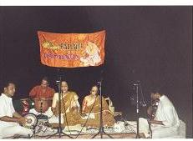
Bombay Sisters and party performing on Aug 8,2004
Pallavi concert at Troy Arts center, Troy,NY

it as the sisters set off with a crisp opening piece ("Jaya Jaya") in the
Ragam Natai. This was followed by very clear, lovely and
learnable renderings of Brochevarevarura (Khamas)) and Manaviyala
(Nalinakanthi).

The two main pieces of the evening were Darini Telusu
(Shuddha Saveri -- shuddha madyamam piece), and Himadrisuthe (Kalyani -
prati madhyamam piece). As music enthusiasts know, it is customary to have
one main piece in the lower madhyama raga ("shuddha") and one in a higher
madhyama raga ("prati"). Shuddha Saveri alapanas are not heard often these
days, and the approach taken by the sisters to the ragam was also
unconventional, though very classical and appealing. Ananthapadmanabhan
gave us memorable alapanas in these two ragas, showing flashes of his
guru. The tani avartanam showed nice coordination and individual
scholarship of the artistes (Tanjore Subramanyam and Sivaramakrishnan).

The main pieces were punctuated in between with a nice Arunachala
Kaviyar song in Hindolam ("Ramanukku"). The main piece was followed by a
number of appealing compositions and tukadas of several composers.
I would give particular mention to an oothukaadu song in Neelambari and a
memorable "Kurai onrum illai" by Rajaji. Enthusiasts know Rajaji as a
politician and scholar; but he also gave us this unusual ragamalika that
has sahitya stating to Krishna, not that we need anything, but that we are
satisfied with what we have and his presence! Inspired by this rendering I
went to my carnatic music archive web page and have notated this song with
meanings.

Overall, the concert was memorable for its classicism, unhurried and
poised krithi renditions and crisp manodharma that the Bombay Sisters are
renowned for. Please do attend Pallavi concerts in person to taste the
sweetness of our great musical tradition, given to us directly by such
great visiting musicians!

Concert Songs (Compiled by Dr. Krishnamoorthy)
Song 1 kriti/Nattai ;Song 2 Brochevarevarura / Mysore Vasudevachar/Khamas ;Song 3 Manavi Alakinchara/Thyagaraja/Nalinakanti ;Song 4 Dharini Telusu konti/Thyagaraja/Suddha Saveri Big Piece
Song 5 Ramanukku Mannan mudi/Arunachala Kavirayar(Rama Natakam)/Hindolam ;Song 6 Himadri suthe/Shyama Sastry/Kalyani (with Niraval) - Big Piece ;Song 6b Tani Avartanam ;Song 7 Oothukkadu/Neelambari ;Song 8 Ninnu Daya/Purandara Dasa/Chadra Kauns ;Song 9 /Darbari Kannada/Jayadeva Ashtapadi ;Song 10 Nanda Nandana Gopala/Narayana Theertha/Ragamalikai ;Song 11 Kurai Onrum Illai/Rajaji/Ragamalikai? ;Song 12 Mangalam

Navaratri Celebrations: Pallavi Program on October 16 at the Hindu Temple, Albany Hindu Temple will be celebrating Navaratri Festival from October 15-October 22/ As a part of it, Srimathi Vidya Subramanian has volunteered to sing Nava Avarnam kritis composed by Sri Muthuswami Dikshitar in praise of Goddess Amba (Kamalamba). These kritis are in praise of Goddess Kamalamba of Tiruvarur. This temple is a Shakti Peetham. Sri Dikshitar has expertly woven in the lyrics, details of the practice of Sri Vidya Upasana. The set includes nine kritis, one for each avarana (and day of Navaratri) and Ganesa, Guru, Dhyana and Mangala kritis, 13 in all. All are invited to attend this program. . For more information, This is scheduled from 3.30-5.30 PM on Saturday October 16 at the Temple. Community members are encouraged to sing songs during this time. Details will follow. Vidya is coordinating this Pallavi event Please call Vidya at 373-9037 for more details.

Other Upcoming Pallavi Concerts
Sunday Oct 24th - Violin Duet Recital by Padma Shankar and Vittal Ramamurthy (Disciples of Sri Lalgudi Jayaraman) on October 24 Steamer 10 Theater 3 PM (social hour at 2:00 PM) (details forthcoming)
Friday Nov 19th -Vocal Concert by "Super Star" Sri Sanjay Subramaniam on November 19, 2004 at 7 PM.(details forthcoming)

Other events
Gita Yagnya on Sunday, Sept 12
Hindu Temple will be conducting Gita Yagnya from 8.30AM to 2 PM. Please bring your copy of Srimad BhagavadGita to recite the poem. There will also be discourses by Sri Vishnu Divecha on Sept 10 and 11 from 7-10 PM. For more information, contact MR Balakrishna (371-6852).

Ganesh Chaturthi on Sept 18
Hindu Temple is observing Vinayaka Chaturthi both in the morning ad evening. For more information, contact the Hindu Temple at 459-7272.
Glimpses of India on Sept 25, 2004.
Hindu Temple, Albany is organizing the event “ Glimpses of India” At the Empire State Plaza Convention Center in Albany, NY on September 25 from 11:30 AM to 5 PM. The program includes classical dances and display of traditional Indian attire from the various regions of the land. Booths for the sale of Indian food, jewelry, sarees, paintings, and artifacts will be set up as well as classes in Yoga and Meditation, Stress Management and Breathing Exercises. Admission: $ 5. The net proceeds of the event will go to support the Hindu Temple Cultural ,Center, being built in the temple grounds. For more information, please call Swatantra Mitta (399-0638) or Sunderesh Heragu (374-7867)

GE Matching Grant for Pallavi
GE Foundation approved Pallavi last year as one of the organizations eligible to receive GE matching grants. GE matches dollar to dollar the donations made to Pallavi by GE employees and retirees. This helps us greatly to make up the losses we incur in organizing various concerts. Pallavi received donations equal to $ 1350 last year from this class of persons. One of the requirements to continue in the program is to get at least $ 1000 in donation by at least 10 distinct donors. We are very much short of these twin goals for this year. An appeal is made to all GE employees and retirees to make a donation to this year as well and register it with GE foundation. For details and information on the procedure to follow, please visit Pallavi’s website (address is given in the beginning of this letter) .

Membership for 2004
Several members have renewed their membership for the year 2004. Thanks for all of them. There are still a few who have not renewed their membership for this year. Please renew your Pallavi membership as soon as you can. We still have three major concerts for this calendar year. Memberships and donations help us to organize the concerts. Please renew or become a new member and support music activities in the capital district. You can send the check to Pallavi of the Capital District, P. O. Box 1732, Latham, NY 12110. Pallavi has obtained tax exemption status under section 501(c) of the IRS code.

Welcome New members and Donors

Arul and N.Balasubramaniam ( Patron/Promoter)
Narendran Paliath

GE Matching Gift Donors

K and Vidya Subramaniam
Prameela Susarla and Anurag Gupta
Gregg and Nicole Steuben

Annual Membership Categories
Family Patron (Admission to all concerts free for two people) $120
Individual Patron (Admission to all concerts free for $ 60
The individual)
Family Membership (Pass for two people for one concert) $ 30
Individual Membership (Pass for one concert for $ 20
The individual)
Student Member (Admission to all concerts free) $ 10
Life Member (Admission to all concerts free for two people for $400
Four years)
Note: Life membership fee can be paid in two consecutive annual installments of $200 each or in one installment of $400.

Annual Special Donation Categories

Patron/Promoter $500
Sponsor/Promoter $250
GE matching Gift Donors
Patron/Promoter and Sponsor/Promoter Donors will be recognized at every event of Pallavi during the year as Patrons or Sponsors.

MEMBERSHIP APPLICATION FOR CALENDAR YEAR 2004

____________________________ __________________________
Last name First name

Spouse (if applicable) ________________________________
Mailing address __________________________________

Phone: _______________________
E mail address________________________________
Activities you would like to be involved ____________________________________(Some of the activities are : hosting of artists, fund raising, Brochure preparation, Food, collections at the desk, membership promotion, newsletter, mailing etc) Please make your checks payable to “Pallavi of the Capital District” and mail to the above address: Pallavi, PO Box 1732, Latham, NY 12110.

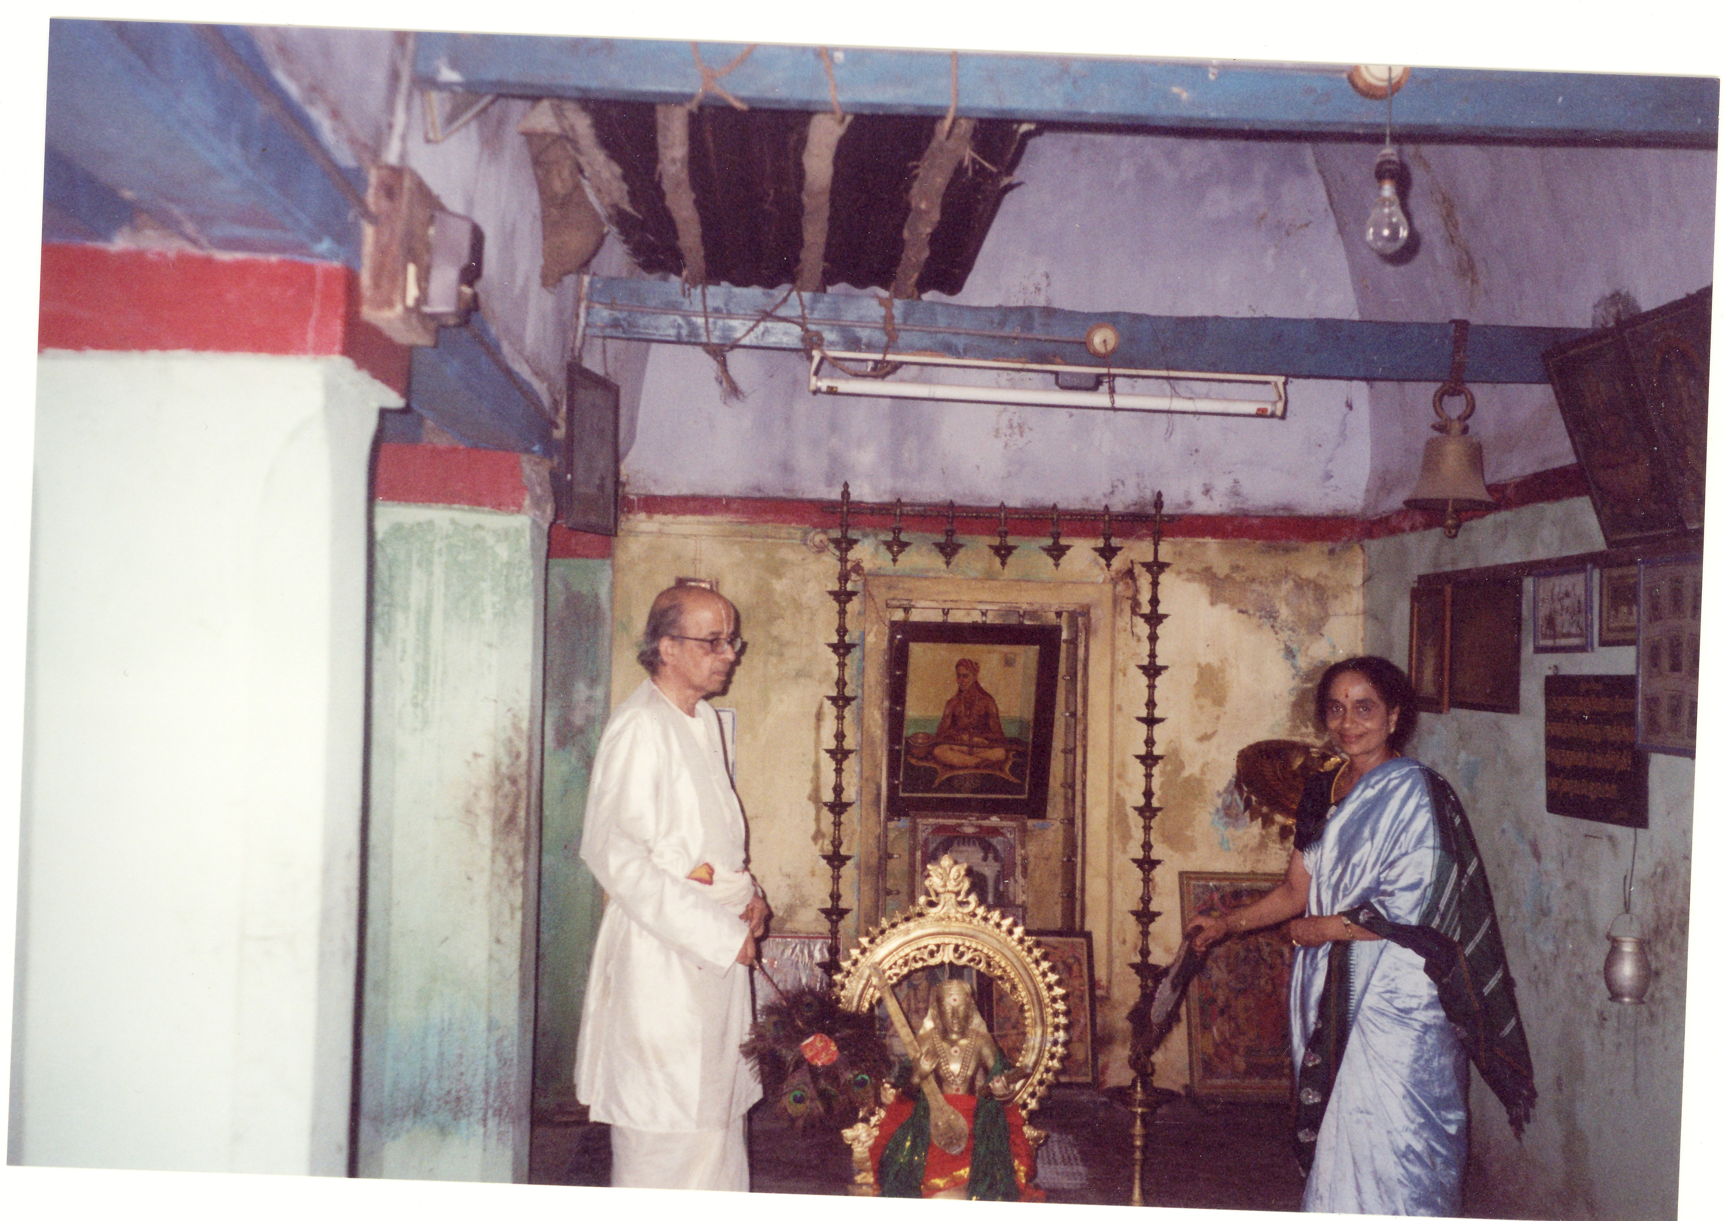
Saint Thyagaraja’s residence in Thiruvayyar near Tanjavur in South India

