Padmabushan Professor T.N. Krishnan

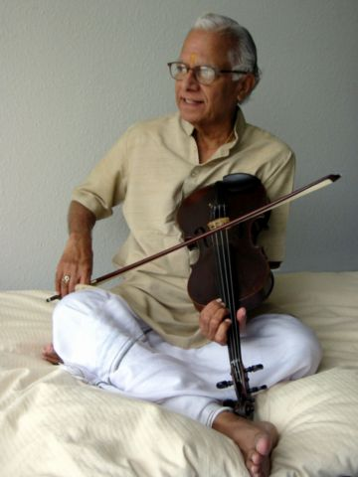
Prof T.N.Krishnan is universally regarded to be the most celebrated violinist of Carnatic music in the world today. Boasted by a rich experience spanning six decades or more, Krishnan brings with him a repertoire that has few or no equals in his field. Over the next several decades, Krishnan has performed on stage with all leading musicians whose list is virtually a “Who’s who in Carnatic music”.
Prof. T. N. Krishnan has traveled and performed all over the world, promoting Indian classical music for the past sixty years. He has visited the United States, Great Britain, France, Germany, Austria, Australia, the former Soviet Republics, the Middle and Far East.
T. N. Krishnan has been closely associated with several national and international institutions engaged in the preservation and development of the arts. He has served as the Vice-Chairman of the Sangeet Natak Academy. He has also chaired various committees for the All India Radio and state universities and academies. He has served at the State Music College in Chennai as Professor of Music and subsequently as its Principal. He also went on to serve as Dean of the School of Music and Fine Arts at the University of Delhi.
Master Rohan Krishnamurthy

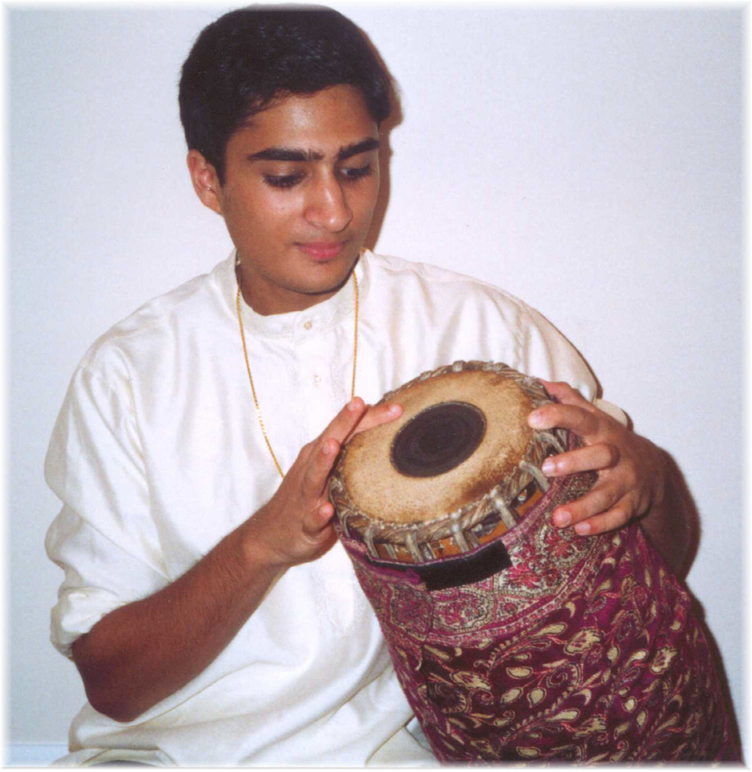
Hailed by senior musicians and music critics as a “percussion prodigy,” and “Virtuoso” by the celebrated Davidson Institute for Talent Development, teenager Rohan Krishnamurthy from Michigan began learning the mridangam at a very young age under Damodharan Srinivasan and later under the mridangam maestro Guruvayur Dorai. Rohan is the recipient of prestigious awards, notably “Yuva Kala Bharathi” by Bharat Kalachar in Chennai, India, “Kaashyap Award” by the Naadalaya Academy in Chennai, The Best Mridangist award from Sri Parthasrathy Sabha in Chennai, “The Prodigy in Performing Arts” by the Indo-American Center in New York, the Junior and Senior competition awards at the Cleveland Aradhana.

Directions to Venue: Academy Hall, Auditorium (2nd Floor). RPI
The Hall is located at the corner of 15th and College Avenue. Academy Hall is old school 14. There is parking at academy hall (you can also park in Visitor center near the walk bridge) and
it is within two blocks of visitors information center. You can also park at the Hall in front or rear.From I-87 Northway , take exit 7 for Rt 7 East towards Troy. Proceed on Hoosick street (RT 7 East) and turn right on to 15th street. Proceed through four traffic lights. The Academy Hall is on the right after you go under sky walk bridge and pass the new BioTech Building on the right. The auditorium is at the upstairs level and can be accessed by stairs or elevator in the rear.

