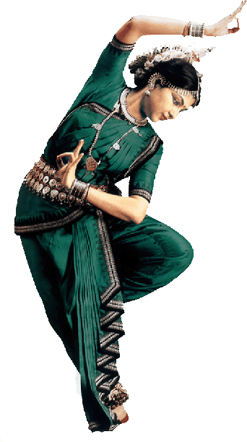
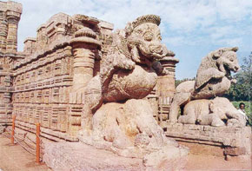
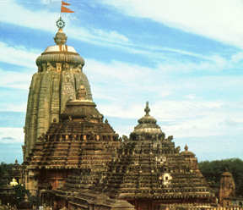
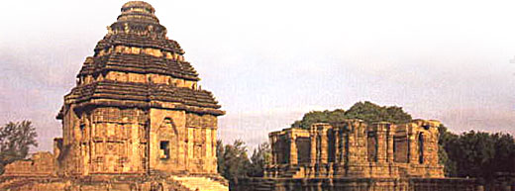
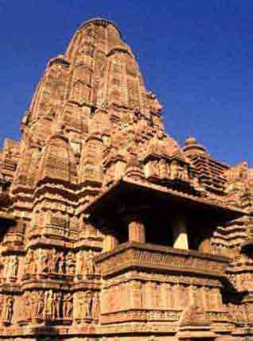

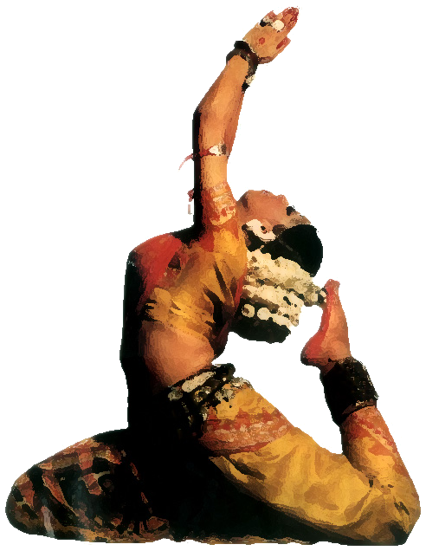
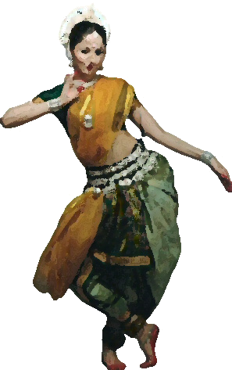
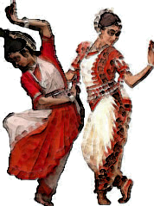

ODISSI DANCE RECITAL BY ALOKA KANUNGO

Experience the grace, lyrical charm, sculpturesque poses, haunting music, and spirituality of Odissi, an ancient Indian classical dance style that can be traced back to 2nd century BC, through the performance of Nritya Shiromani Smt. Aloka Kanungo.
The program will feature the various moods and facets of Odissi dance - the sweet, the graceful, the sculptural, the aesthetical, the technical, the passionate, the vigorous, the dramatic, the poetic, the devotional, and the final surrender to the divine.
All are welcome to attend this free event sponsored by the Union Performing Arts Committee.

Date: Friday, September 14, 2007

Venue: Chapel and Cultural Center, RPI
Time: 7pm – 8:30 pm

