Pallavi of the Capital District and UPAC RPI proudly present…
A Hindustani Vocal concert
by 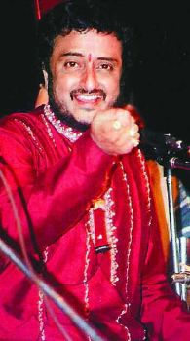
Kaivalya Kumar
with
Ravindra Katoti on harmonium
Shyam Kane on Tabla

Date: Saturday 11/3/07 Time: 6.00PM
Venue: Academy Hall Auditorium, Troy, NY
Tickets: Adult 15/- ; Student 8/- ; Sponsor 50/- Patron 100/-
For tickets & information contact
Nalini Madiwale: 356-2688 nalinim01@yahoo.com
Shekhar Garde: 869-8904 gardes@rpi.edu
Sheela Jaysimha: 371-0227 ragas3@yahoo.com
Pg 1/2
Kaivalya Kumar: Is a disciple of his father Pandit Sangmeshwar Gurav. He is a leading young exponent of the Kirana Gharana. His redition is said to be reminiscent of Abdul Karim Khan sahib.

Ravindra Katoti: Is a disciple Pandit Rambhau Bijapure. He is a dedicated, versatile musician who also works tirelessly for the betterment of the status and recognition ofhis instrument.

Shyam Kane: Is a very popular table player based in the U.S. in the Midwest. He is flashy versatile and has accompanied many famous artists both western & Indian.

** Kaivalya Kumar is known to excel in Natyasangeet and Vachana Sangeet : here is an opportunity to hear these unique Marathi & Kannada compositions in the second half of the concert.

Please make checks payable to Pallavi of the Capital District & mail to me at 2002 Philomena Dr Schenectady, NY 12303

Directions: Academy Hall is on the RPI campus at the corner of 15th St and College Ave. This is a T junction that curves a little to the right. To get to 15th St. you would take Hoosick St. from alternate Route 7.

Pg 2/2

