Pallavi of the Capital District
Presents….
A Hindustani Vocal Concert
By
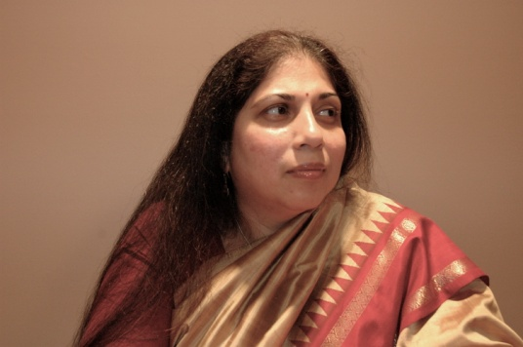
Usha Kallianpurkar
with
Amod Dandawate on Tabla
& Kedar Naphde on Harmonium
Date: Sat. 3/14/09 Time: 7.00PM
Venue: 2002 Philomena Dr in Guilderland
Postal address Schenectady, NY 12303

Adults: 15/- Students: 10/- Children 10-18: Free
Contact:
Nalini Madiwale: 356-2688 nalinim01@yahoo.com
Avinash Taware: 371-2594 taware@crd.ge.com
Artist Bio: All these accomplished artistes are from NJ. All of them hold a full time job and manage a busy performance schedule. They have performed in prominent venues like the Lincoln Ctr.
Usha Kallianpurkar: Started training when she was seven. A tortuous path eventually brought her to the late Pt. Firoz Dastur.
She now receives guidance from Pt Madhav Bhatki.
She has performed extensively in Europe, India, the US and Australia. She also collaborates with prominent Jazz artistes.
She has not performed in Albany before.
Amod Dandawate: Was initiated into percussion by his father Shri Vasantrao Dandawate. He is a disciple of Pt. Samir Chatterjee.
We have heard Amod when he performed with Smt. Shubra Guha.
Kedar Naphde: His first teacher was his grandfather Shri Dadasaheb Naphde. He is a disciple of Pt. Tulsidas Borkar.
He has accompanied just about every visiting Vocalist. We have heard Kedar when he accompanied Smt Ahswini Bhide.

Directions: Route 87 to 20 W (Western Ave) Right on Route 146 (Carman Rd). About 1.2 miles , Right on Spawn , ½ a mile up, right on Philomena. We are the corner of Spawn & Philomena.
Arrangements: Please make checks payable to Pallavi of the Capital District and mail to 2002 Philomena Dr Schenectady, NY 2303
Please let me know in advance if you need to be seated on a chair or sofa.
Please let me know if you need a ride: I could put you in touch with someone coming from your side of town.

