Hindu Temple Society

Presents a

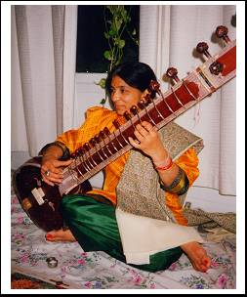
5 Week Course

Indian Classical Music

By
Prof. Veena Chandra

FREE CLASSES
Hindu Temple Cultural Center
450 Albany Shaker Rd. Loudonville

Play, Learn, appreciate: Indian Classical Music
TIME: 11AM- 12:30PM
Class Dates: SUNDAYS 5/31/09: 6/14/09: 6/28/09: 7/5/09
Finale performance day 7/12/09

Register: V. Chandra (518) 786-1309 vchandra@skidmore.edu
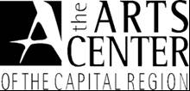

This project is made possible in part through Community Arts Grants a program funded through the State and Local Partnership Program of the New York State Council on the Arts and The Arts Center of the Capital Region.

