Hindu Temple Society

Presents

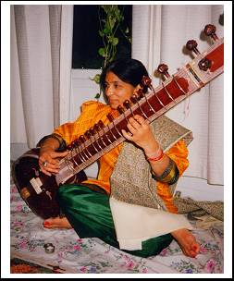
Workshop & Performance

In Classical Indian Music

By
Prof. Veena Chandra

A FREE EVENT

Sunday March 22nd 2009
10:45am to 12:15pm

Location: Hindu Temple Cultural Center
450 Albany Shaker Rd. Loudonville

Community Enrichment Project Learn to Enjoy Indian Music & Rhythm
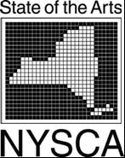
Contact: V. Chandra (518) 786-1309 vchandra@skidmore.edu

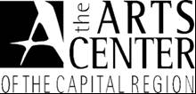
This project is made possible in part through Community Arts Grants a program funded through the State and Local Partnership Program of the New York State Council on the Arts and The Arts Center of the Capital Region.

