Zachary Cross
Daylight simulation

This semester, I plan on working with Dr. Cutler to explore, experiment, and hopefully implement non-photorealistic rendering of for architectural models. One of the problems that may deter architects from using a computer model to show off concepts and design for a given model is that the resulting model is often rendered as photo realistically as possible. The resulting image is very crisp and precise, even if the model is meant as a concept only. This leads the client to view the rendering as final in terms of materials and placement. The architect, on the other hand, may be trying to show how the lighting may affect a room or even just give a general impression of the mood created by the building. The hope is that the use of non-photorealistic rendering will enable the architect to present whatever aspect of the design process he wished to without giving the impression of finality.
The first step is to work with post-rendering image manipulation. This will help to try and establish what exactly non-photorealistic rendering should or could be.

The first step was to come up with a suitable model to test. I tried to import SketchUp models, but was unable to without the educator’s (pro) edition. So I decided to make a simple one, seen below.
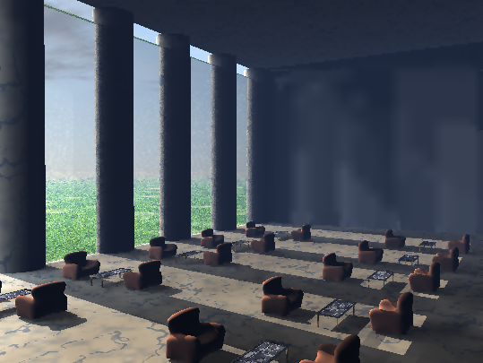
This image is rendered with the lowest quality setting initially. The sun is placed far off the upper left sides of the screen. Slight GI was used, as can be seen by the anomalies on the back wall.
I used The GIMP 2.2 for all of the image manipulation. First I did a simple blur.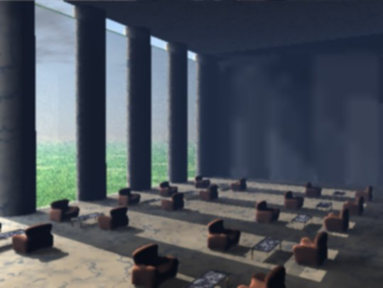

This blur does not improve the overall quality of the image, nor does it do much to focus attention on the lighting of the room.
The next technique was a selective Gaussian blur. This blurred only parts of the image, though it still resulted in a fairly poor image along with the anomalies in the back.
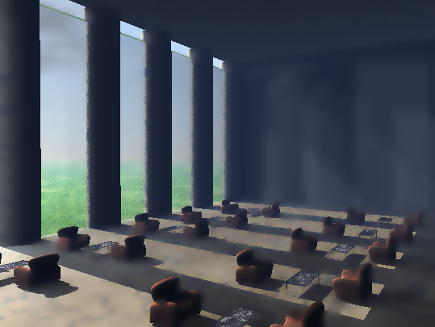

The next one is pixilation, which resulted in a very sloppy picture, as if it had been blown up too much.
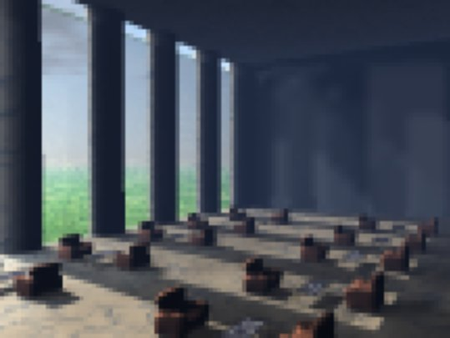

The next one is called erode, and it comes closer to smoothing out the picture in a way that makes it appear less final. The anomalies still exist, and the smoothing is not perfect, resulting in a sloppy looking picture.
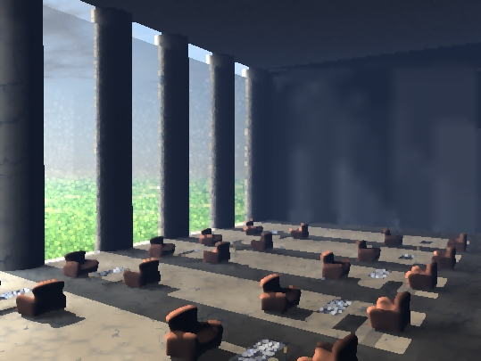
This one is called a Sobel edge detection. Now, I thought it looked pretty cool, but it doesn’t accomplish much. While it definitely achieves the non-final look, it doesn’t convey the lighting of the scene well at all. In fact, it makes the sky look like a cave ceiling.
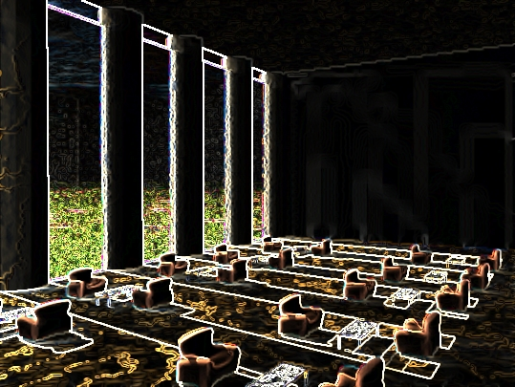

There are a great deal of ‘artistic’ filters available, which had varying degrees of success, though none a great job of focusing the attention where I wanted it. This example here is called ‘cubism.’
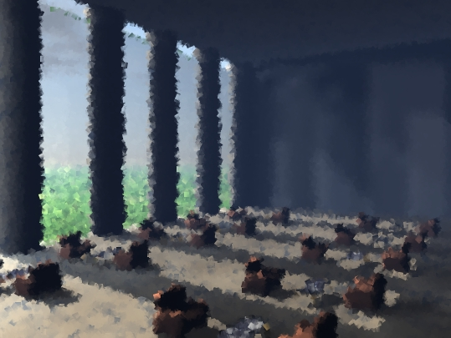

The last example came the closest to accomplishing the goal of focusing attention of the light and removing a sense of finality. It is a technique called ‘non-adaptive recursive despeckling.’
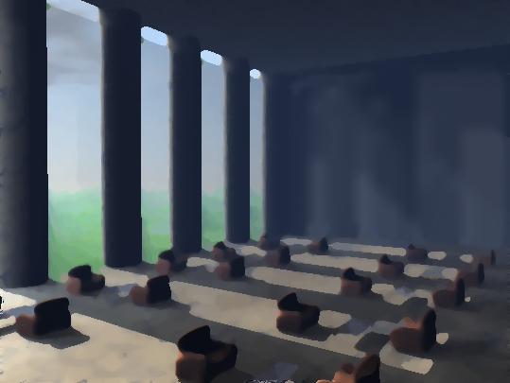

From these simple experiments, it seems that the best way so far to focus attention and remove finality is to use some sort of blurring or subtraction to remove some of the rigid lines. The anomalies remain on the back wall, although that may be due to the low quality of initial rendering.

